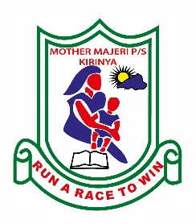**MOTHER MAJERI NURSERY SCHOOL**

**END OF TERM II EXAMINATION, 2024**

**CLASS : TOP CLASS**

**SUBJECT : MATHS**

**My name is :__________________________________________Stream_________**

**1. Circle the bigger number.**

8 and 11 6 and 26

10 and 20 2 and 1

99 and 16

**2. Write their number names.**

1 - ______________ 3 - ________________

4 - ______________ 20 - ______________

8 - ________________ 16 - _______________

**3. Take away/subtract.**

6 9

- 3 - 7

4 6

- 0 - 6

**4. Match correctly.**

Tue Thursday

Sun Wednesday

Mon Saturday

Fri Monday

Wed Friday

Sat Sunday

Thur Tuesday

**5. Add correctly.**

2 + 1 + 4 = 7

4 + 3 + 4 =

8 + 0 + 2 =

6 + 3 + 0 =

Five apples plus two apples equals __________ apples.

Six balls plus three balls equals __________ balls.

**6. Read and draw pictures.**

|  |  |  |  |
| --- | --- | --- | --- |
|  |  |  |  |
| three girls | two trees | five boxes | three baskets |

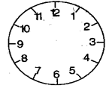**7. Tell the time.**



It is ____o’clock





It is ____o’clock





It is ____o’clock

**END**